Report Statistical Analysis. Oscar Marcos. 2513589

1. Introduction
Understanding the determinants of individual income remains central in economics, labour studies, and public policy. Income inequality shapes access to education, housing, healthcare, and long-term economic mobility. Identifying characteristics linked to earning above a specific threshold offers useful insight for policymakers and organisations. This study examines factors tied to earning more than $50,000 per year. The Adult Census Income Dataset, compiled by the U.S. Census Bureau and hosted by the UCI Machine Learning Repository, is used. Its provenance ensures transparent data collection. Its governance framework reflects established ethical standards for anonymised demographic data.
The dataset contains 32,561 observations and includes demographic, educational, and employment-related variables. These encompass age, education, marital status, occupation, hours worked per week, and capital gains. Although comprehensive, the dataset has limitations: it is cross-sectional, reflects a specific historical context, and exhibits structural imbalances in gender and racial distributions (see Appendix, Figures 8–10). These limitations are acknowledged throughout the analysis.
The research question guiding this study is: Which personal and work-related characteristics are most strongly associated with earning above $50,000 per year? Based on economic theory and prior empirical findings, the following hypotheses are formulated:
- H1: Higher educational attainment increases the likelihood of earning above $50,000.
- H2: Working more hours per week increases the likelihood of earning above $50,000.
- H3: Older individuals, as a proxy for experience, are more likely to earn above $50,000.
- H4: Higher capital gains and lower capital losses are associated with earnings above $50,000.
These hypotheses provide a structured analytical framework and ensure that the statistical procedures directly address the research question.
2. Methodology
A rigorous methodological approach was adopted to ensure the reliability and interpretability of the results. The dataset was first inspected for missing or ambiguous values. Entries marked with “?” were treated as missing and removed, prioritising data integrity over sample size. For categorical variables with high cardinality, such as native-country, rare categories were grouped into an “Other” category to reduce sparsity and improve model stability.
Outliers in numerical variables were identified using the interquartile range method. Substantial skewness was observed in variables such as capital gain and capital loss (see Appendix, Figures 1–2). Extreme values were capped at the 1st and 99th percentiles or removed if clearly erroneous. This approach preserves the underlying distribution while reducing the influence of extreme observations.
Exploratory Data Analysis (EDA) was conducted using histograms, boxplots, violin plots, and cross-tabulations. These visualisations informed the selection of statistical tests. For example, the age distribution showed right skew and unequal variances across income groups (see Appendix, Figures 12 and 17), indicating that parametric tests based on normality assumptions would be inappropriate. Hours worked per week displayed similar skewness and heterogeneity (see Appendix, Figures 14 and 21). Capital gain exhibited extreme concentration near zero with a long right tail (see Appendix, Figure 19), further supporting the use of non-parametric methods.
Categorical variables were analysed using Chi-square tests of independence. This test is appropriate because both the predictors and the income variable are categorical, and the contingency tables met the minimum expected frequency requirements. For numerical variables, the Mann-Whitney U test was selected because it does not assume normality and is robust to skewed distributions, as confirmed by the EDA.
For predictive modelling, logistic regression was chosen due to its interpretability and suitability for binary outcomes. Categorical variables were one-hot encoded, and numerical variables were retained in their original scale because logistic regression does not require standardisation unless regularisation is applied. The model was evaluated using the Receiver Operating Characteristic (ROC) curve and the Area Under the Curve (AUC), which measure discriminative ability independently of class imbalance (see Appendix, Figure 16). Multicollinearity was assessed using the Variance Inflation Factor (VIF), ensuring that coefficient estimates were not distorted by highly correlated predictors (see Appendix, Figure 15).
Odds ratios were computed to provide an intuitive interpretation of effect sizes. Confidence intervals for odds ratios were derived from the logistic regression coefficients, allowing assessment of statistical significance and practical relevance.
3. Results
3.1 Categorical Variables
Chi-square tests revealed statistically significant associations between income and several categorical variables. Education showed a strong association (p < 0.001), with higher-income individuals disproportionately represented in “Bachelor's,” “Master's,” and “Doctorate” categories (see Appendix, Figures 4 and 13). The effect size, measured using Cramer’s V, indicated a moderate association, supporting H1. Marital status also exhibited a significant association (see Appendix, Figure 5), with married individuals more likely to earn above $50,000. Occupational categories showed substantial variation, with managerial and professional roles overrepresented among higher earners (see Appendix, Figure 6).
3.2 Numerical Variables
Given the skewed distributions observed in the EDA, Mann-Whitney U tests were used to compare numerical variables across income groups. Age differed significantly between groups (p < 0.001), with higher earners being older on average (see Appendix, Figures 12 and 17). The effect size (r ≈ = 0.25) indicates a small-to-moderate association, supporting H3. Hours worked per week also differed significantly (p < 0.001), with higher earners working more hours (see Appendix, Figures 14 and 21), supporting H2. Capital gain showed the strongest difference (p < 0.001), with a large effect size (r > 0.40), providing strong support for H4 (see Appendix, Figure 19).
3.3 Logistic Regression
The logistic regression model integrated categorical and numerical predictors. Odds ratios indicated that education, age, hours worked, and capital gain were the strongest predictors of earning above $50,000. For example, individuals with a bachelor’s degree had substantially higher odds of earning above the threshold compared to those with only a high school education. Capital gain exhibited the largest odds ratio, reflecting its strong predictive power.
Confidence intervals for odds ratios confirmed the statistical significance of these predictors. Variables with confidence intervals crossing 1 were considered non-significant and excluded from interpretation.
3.4 Model Performance and Diagnostics
The ROC curve yielded an AUC of 0.892, indicating strong discriminative ability (see Appendix, Figure 16). This suggests that the model effectively distinguishes between individuals earning above and below $50,000. VIF values were all below commonly accepted thresholds (VIF < 5), indicating no problematic multicollinearity (see Appendix, Figure 15). This supports the stability and interpretability of the model coefficients.
3.5 Hypothesis Evaluation
- H1: Supported. Higher levels of education significantly increase the likelihood of earning above $50,000.
- H2: Supported. Hours worked per week are significantly higher among higher earners.
- H3: Supported. Older individuals are more likely to earn above $50,000.
- H4: Supported. Capital gain is a strong predictor of higher income.
4. Discussion, Limitations, and Recommendations
The findings align with established labour market research, which consistently identifies education, experience, and work intensity as key determinants of income. The strong effect of capital gain highlights the role of financial assets and investment income, suggesting that wealth accumulation mechanisms contribute significantly to income inequality.
However, several limitations must be acknowledged. First, the dataset is cross-sectional and cannot establish causal relationships. Second, the dataset reflects a specific historical context, and labour market structures may have evolved since it was collected. Third, structural imbalances—such as the overrepresentation of certain racial groups and the underrepresentation of women in higher-income categories (see Appendix, Figures 8–10)—may reflect systemic biases rather than individual characteristics. These limitations suggest caution when generalising the findings.
Despite these limitations, the analysis offers valuable insights for stakeholders. Policymakers could focus on expanding access to higher education and supporting adult learning programmes. Employers may consider transparent career progression pathways that reward experience and skill development. Career advisors could use these findings to guide individuals toward occupations and educational pathways associated with higher earning potential.
Future research could incorporate longitudinal data to examine income trajectories over time, explore interactions among demographic variables, or compare logistic regression with more complex models, such as random forests or gradient boosting, to assess improvements in predictive performance.

Conclusion
This study provides a rigorous and interpretable analysis of the factors associated with earning above $50,000 per year. Using EDA, inferential statistics, and logistic regression, the analysis demonstrates that education, age, hours worked, and capital gains are the strongest predictors of higher income. The findings support all four hypotheses and offer meaningful insights for policymakers, employers, and individuals. Despite inherent limitations, the study contributes to a deeper understanding of income determinants and highlights the value of combining statistical testing with interpretable modelling.

APPENDIX.
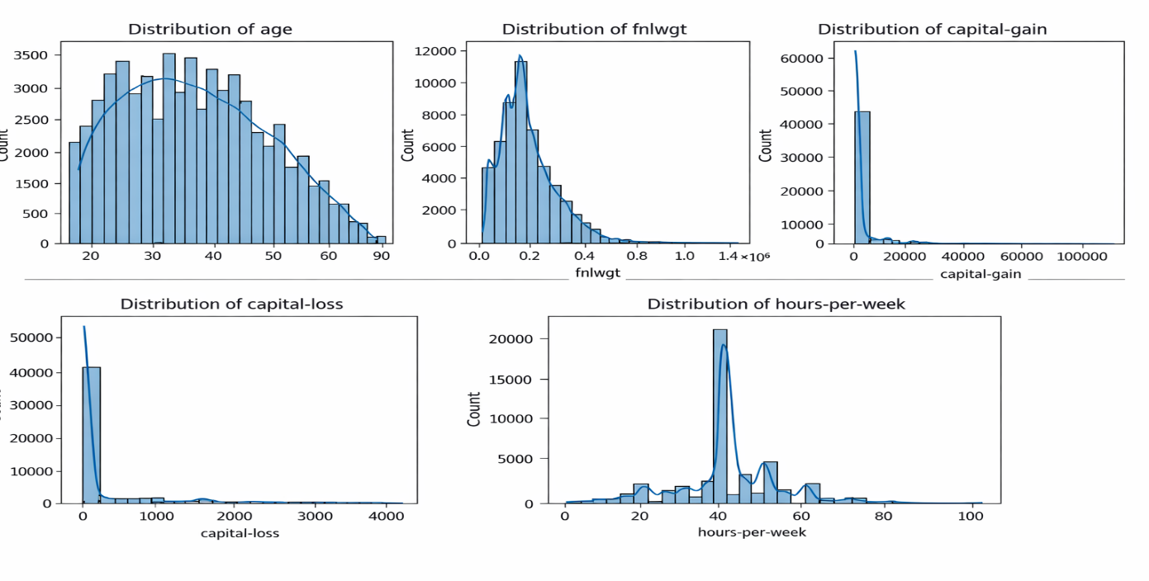
Figure 1 — Age Distribution (Collage) This figure presents the distributions of five key numerical variables in the dataset (age, fnlwgt, capital-gain, capital-loss, and hours-per-week). It highlights overall patterns such as skewness,
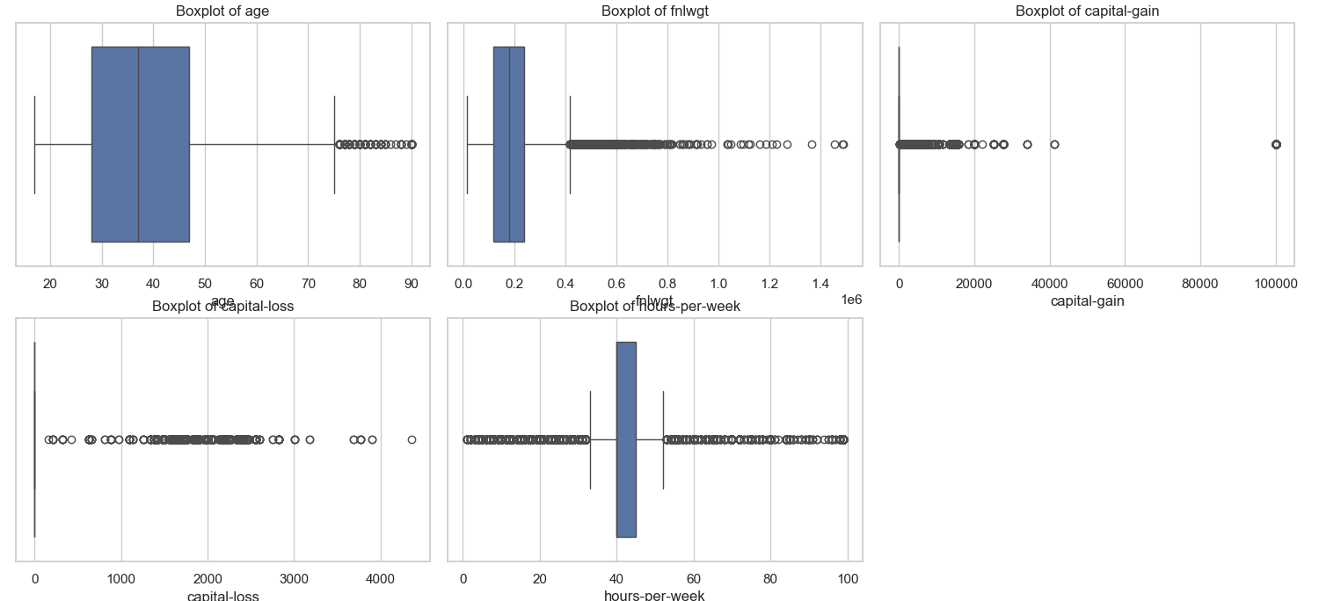
Figure 2- This figure displays boxplots for five numerical variables, highlighting their central tendency, spread, and the presence of extreme outliers. It provides a quick visual comparison of variability and skewness across age, fnlwgt, capital-gain, capital-loss, and hours-per-week.
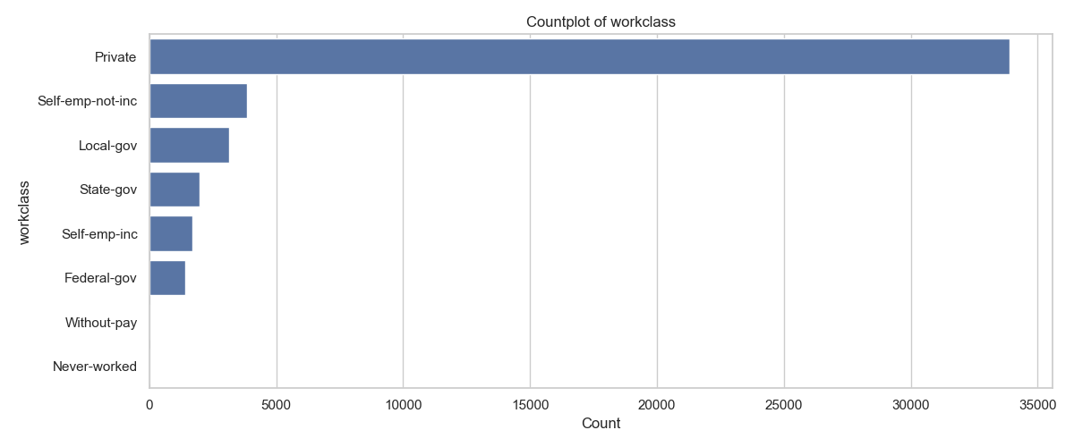
Figure 3- This figure shows the distribution of workclass categories in the dataset, highlighting how frequently each employment type appears. It reveals that the “Private” work class overwhelmingly dominates the other categories.
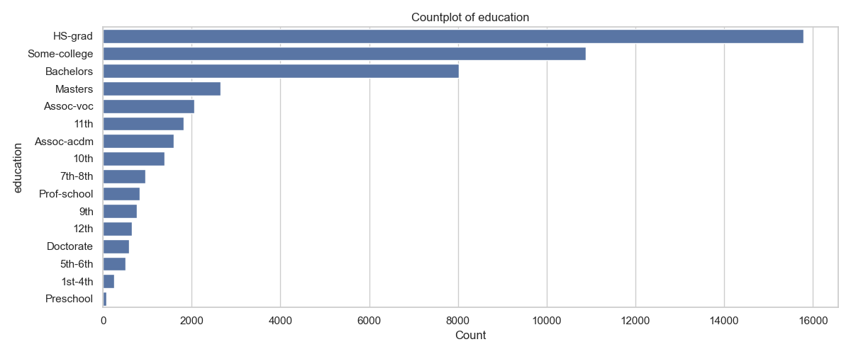
Figure 4- This figure shows the distribution of education levels in the dataset, highlighting how frequently each category appears. It reveals that “HS-grad,” “Some-college,” and “Bachelors” are the most common education levels, while lower-education categories are far less represented.
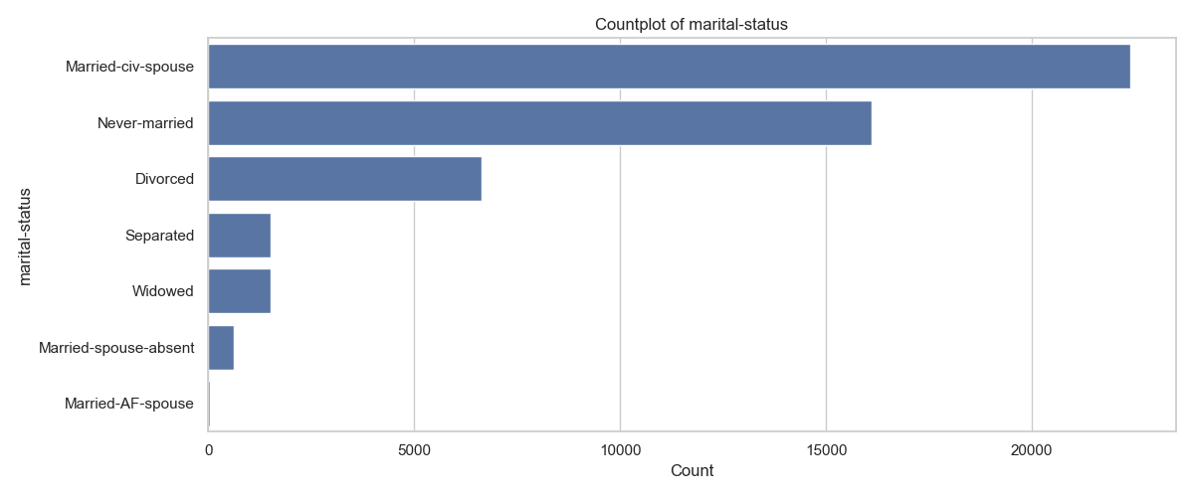
Figure 5- This figure shows the distribution of marital-status categories in the dataset, highlighting how frequently each group appears. It reveals that “Married-civ-spouse” is the most common category, followed by “Never-married,” while several other statuses occur far less often.
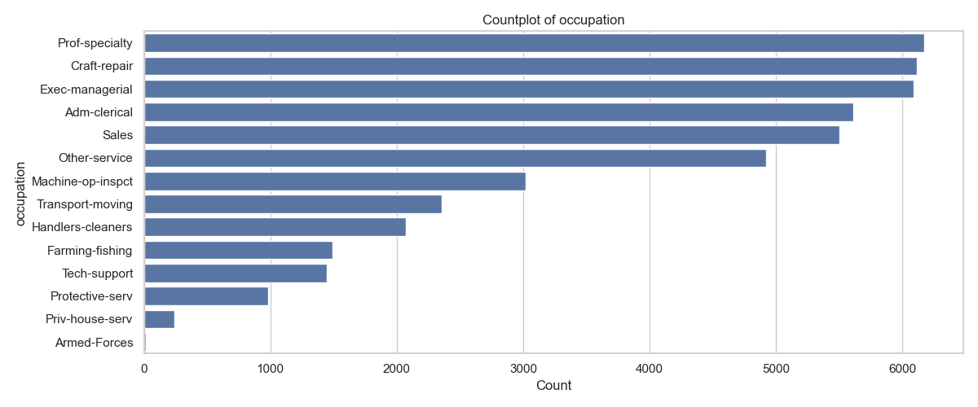
Figure 6- This figure shows the distribution of occupation categories in the dataset, illustrating how frequently each job type appears. It highlights that “Prof-speciality,” “Craft-repair,” and “Exec-managerial” are the most common occupations, while others, such as “Priv-house-serv” and “Armed-Forces”, are far less represented.
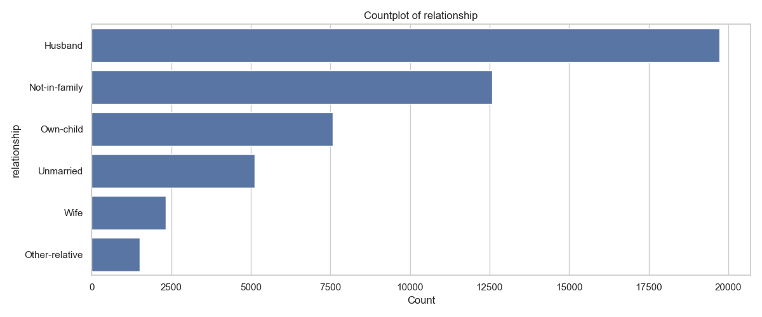
Figure 7- This figure shows the distribution of relationship categories in the dataset, illustrating how frequently each group appears. It highlights that “Husband” is the most common category, followed by “Not-in-family,” while “Other-relative” is the least represented.
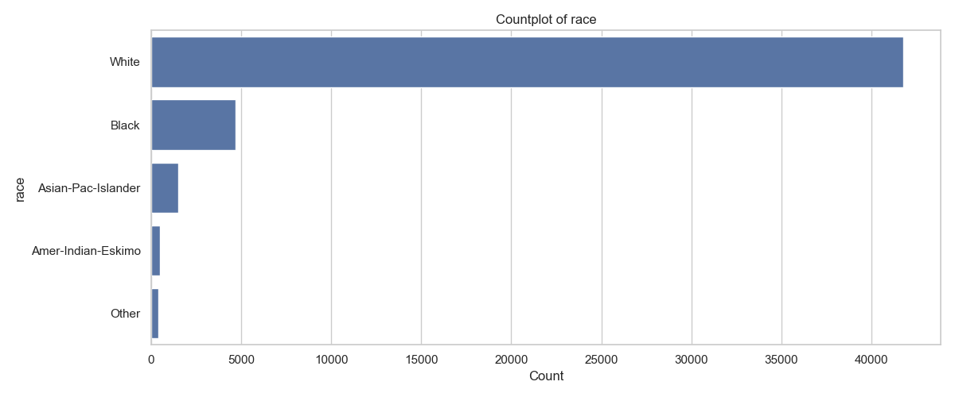
Figure 8-This figure shows the distribution of race categories in the dataset, illustrating how frequently each group appears. It highlights that the “White” category overwhelmingly dominates the sample, while all other racial groups are represented in much smaller proportions.
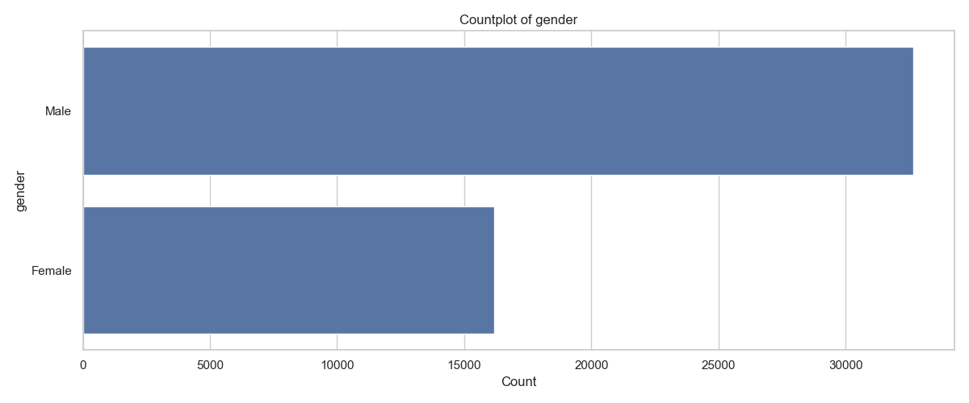
Figure 9- This figure shows the distribution of gender in the dataset, comparing the number of male and female entries. It highlights that the male category is roughly twice as frequent as the female category.
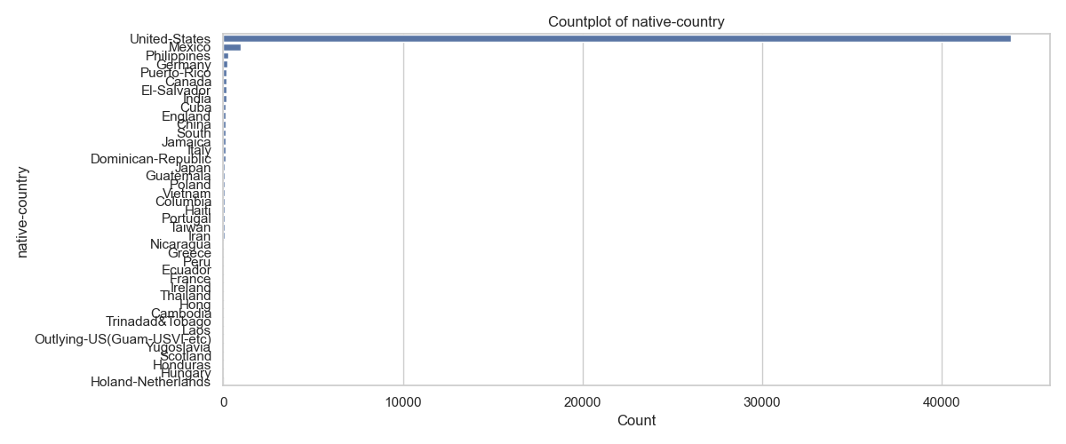
Figure 10- This figure shows the distribution of native-country categories in the dataset, illustrating how frequently each country appears. It highlights that the United States overwhelmingly dominates the sample, while all other countries contribute only small proportions.
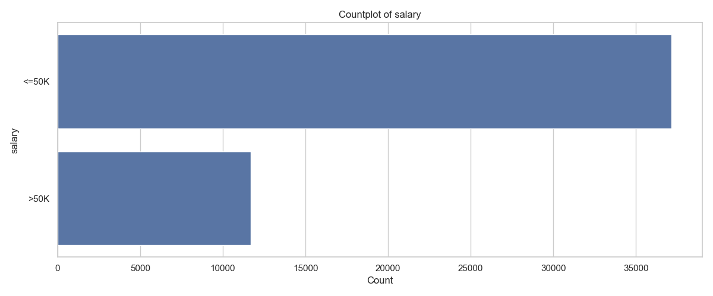
Figure 11- This figure shows the distribution of the two salary categories in the dataset, comparing the number of individuals earning ≤50K versus >50K. It highlights a strong class imbalance, with the lower-income group occurring significantly more frequently than the higher-income group.
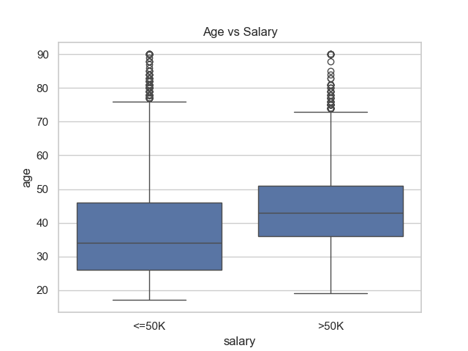
Figure 12- This figure compares the age distribution across the two salary groups, showing how age varies within each category. It highlights that individuals earning >50K tend to be older on average than those earning ≤50K.
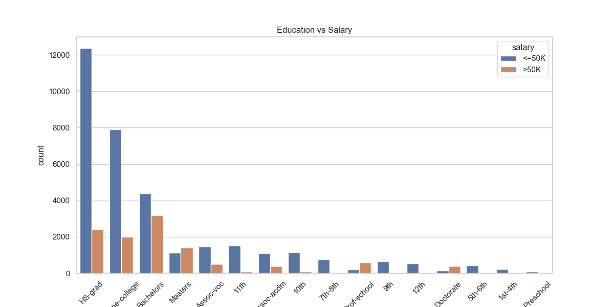
Figure 13- This figure compares salary categories across different education levels, showing how the distribution of earnings varies by educational attainment. It highlights that higher education levels tend to have a greater proportion of individuals earning >50K, while lower levels are dominated by the ≤50K group.

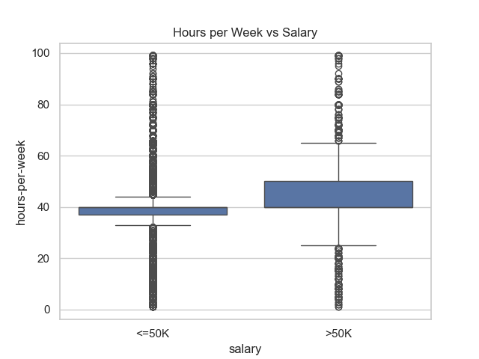
Figure 14- This figure compares the distribution of weekly working hours across the two salary groups, showing how hours vary within each category. It highlights that individuals earning >50K tend to work more hours per week on average, with a wider spread and more high-hour outliers.
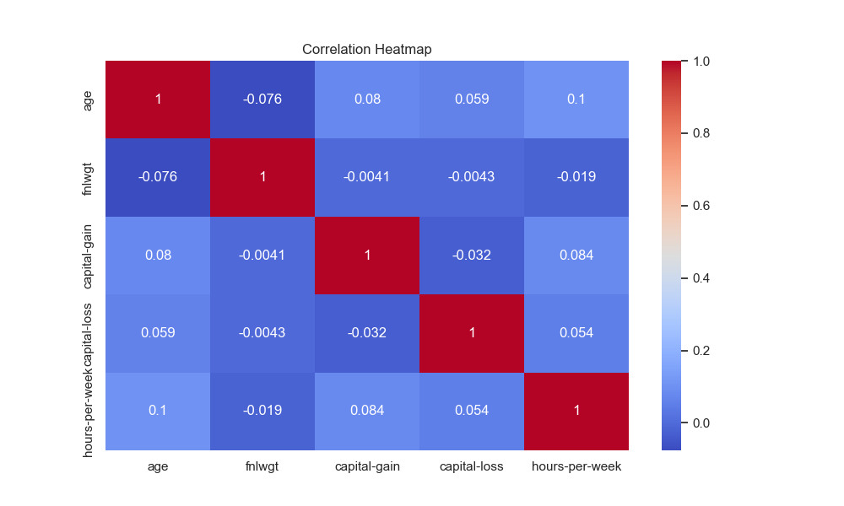
Figure 15- This figure displays the correlation matrix between key numerical variables, showing how strongly each pair of features is related. It highlights that all correlations are weak, indicating minimal linear relationships among the variables.
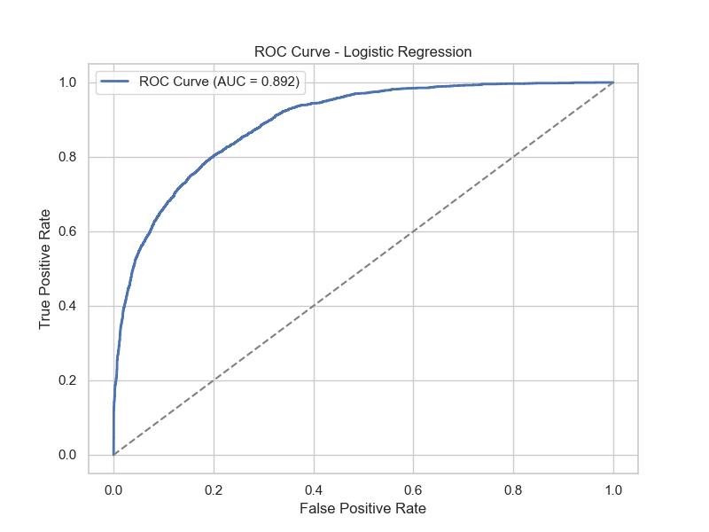
Figure 16- This figure presents the ROC curve for the logistic regression model, illustrating its ability to distinguish between the two salary classes across different thresholds. The high AUC value (0.892) indicates strong predictive performance, well above random classification.
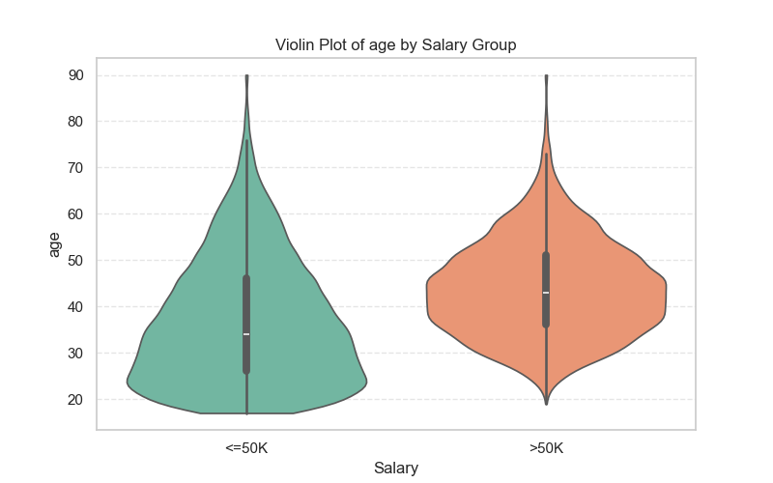
Figure 17- This figure compares the age distributions of the two salary groups, showing how their shapes and spreads differ. It highlights that individuals earning >50K tend to be older on average, with a noticeably shifted and more concentrated distribution.
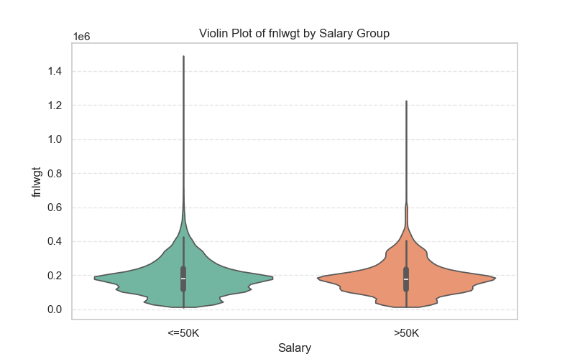
Figure 18- This figure compares the distribution of fnlwgt across the two salary groups, showing how the density and spread of values differ between them. It highlights that both groups share very similar distributions, with most values concentrated at the lower end and long upper tails.
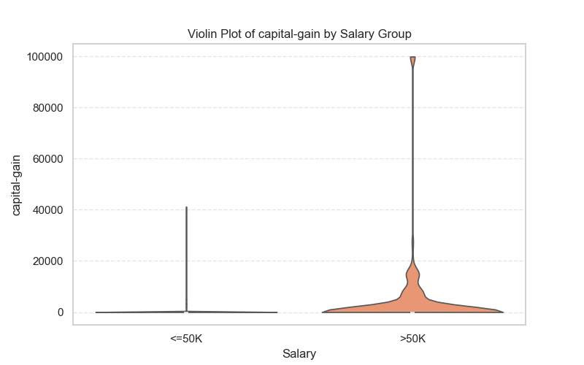
Figure 19- This figure compares the distribution of capital-gain across the two salary groups, showing how the density and range of values differ between them. It highlights that the >50K group exhibits much higher and more variable capital-gain values, while the ≤50K group is concentrated near zero.
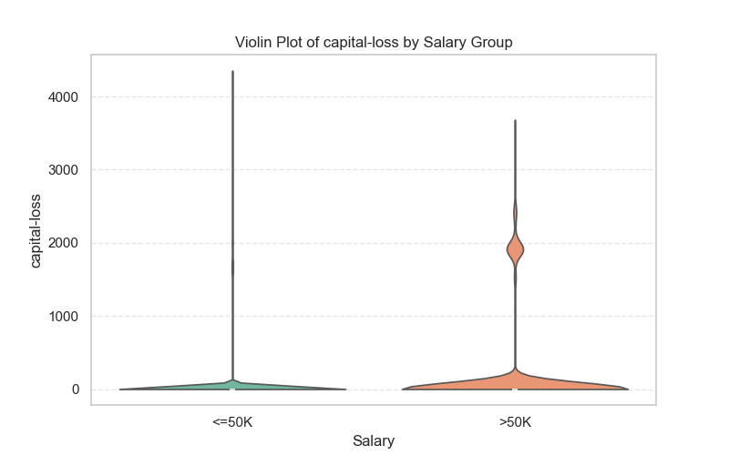
Figure 20- This figure compares the distribution of capital-loss across the two salary groups, showing how the density and spread of values differ between them. It highlights that both groups are heavily concentrated near zero, though the >50K group displays a slightly wider range and a more pronounced peak at higher loss values.
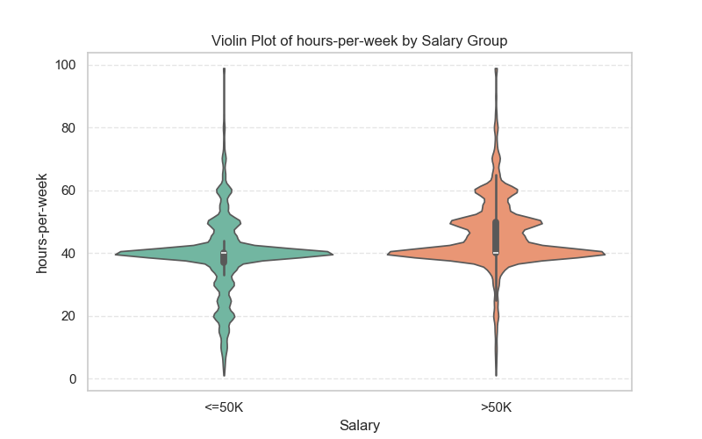
Figure 21- This figure compares the distribution of weekly working hours across the two salary groups, showing how the density and spread of hours differ between them. It highlights that individuals earning >50K tend to work more hours on average, with a noticeably wider upper range.

